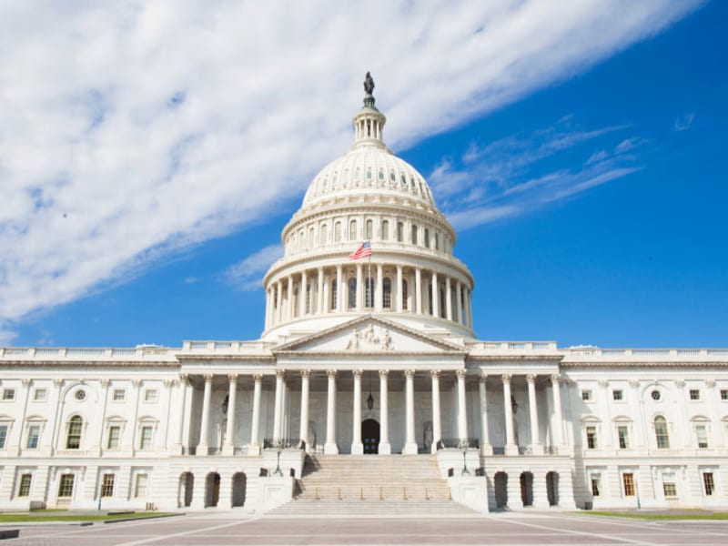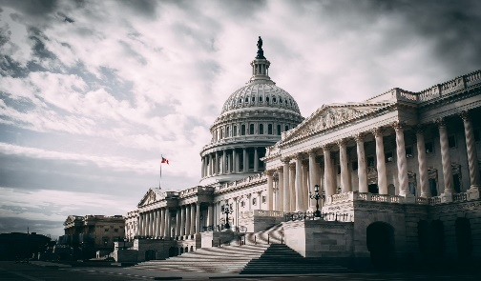-

* **Qualified business best-in-industry solutions.**
* **Exceptional strict Quality Control Standards.**
* **Best of Subcontract Partnerships**
* **Experienced resource pool and recruiting.**

**CAGE:** 8SYT8 **| DUNS:** 087794383 **| Phone:** (314) 319-9333

**COMPANY SNAPSHOT**

O’Kelley Building Maintenance, LLC. is a cleaning company that specializes in post-construction and cleaning government facilities. We are customer-focused with a professional cleaning team.

**• Sanitation Services**

* Enhanced Clean
* Customized Services
* Green Cleaning
* Improved Absence Rates

**• Janitorial Services**

* Background Checked Employees
* EPA Approved Chemicals
* Proven Cleaning Methods

**• Floor Services**

* Carpet Services
* Floor Services
* **One-Time Projects**
* Secure Facilities Projects
* General Cleaning

**Govt. Business POC:** Rashod O’Kelley

**Phone:** (314) 319-9333

**Email: okelbum2019@gmail.com**

**Address:** 1427 Sheridan Dr. Saint Louis, MO 63132

**Work Area:** MO

**CAPABILITY STATEMENT**

okelleybuildingmaintenance

**561720 Janitorial Services**

**561720 Floor Services**

**561720 Sanitizing Services**

O’Kelley Building Maintenance LLC., core competency is sanitizing and janitorial cleaning services; we are a single-source commercial janitorial company. O’Kelley Building Maintenance, LLC. is an experienced provider of sanitizing and janitorial services to the Federal, State, & Local governments as well as commercial customers. Among our strongest competencies is our ability to successfully provide sanitary, secure, safe green cleaning and janitorial services consistently.

➲ ABC Specializes in finding highly qualified personnel placements.

➲ ABC can handle small and medium (30+ personnel) contracts.

➲ ABC has the capability to payroll in all 50 states.

Hint: No long paragraphs. Tailor your Capability Statement to reflect your audience. One very brief paragraph of company description detailing pertinent facts.

**Preferred/Janitorial Cleaning**

* **Homer and Associates**
* **Hog Construction**
* **Patrick H. Durban MDPC Senior Health Center**
* **Family Forward HQ**
* **Brentwood Library**
* **Enterprise Bank St. Charles**
* **Hogan Trucking Annex**
* **St. Louis Lambert Airport**
* **Spirit of St. Louis Chesterfield**

**PAST PERFORMANCE**

**CORE COMPETENCIES**

**NAICS AND OTHER CODES**

**DIFFERENTIATORS**

**Rashod O’Kelley**

MANAGER

okelleybuildingmaintenance

(314) 319-9333

1427 Sheridan Dr Saint Louis, MO 63132